Problem-01: Write a Program to test Default Constructor.
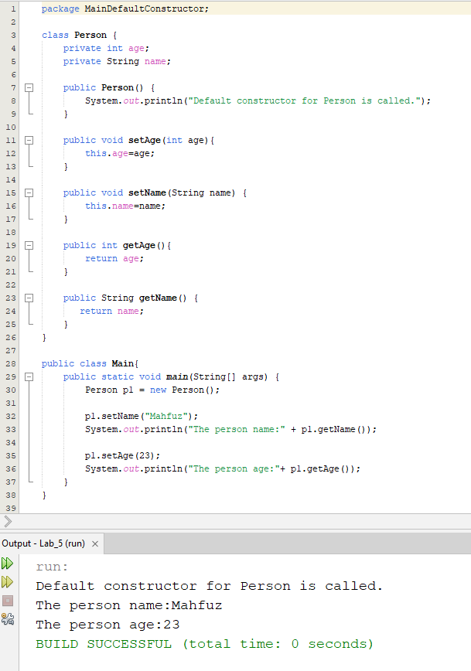
Problem-02: Write a Program to test Parameterize Constructor.
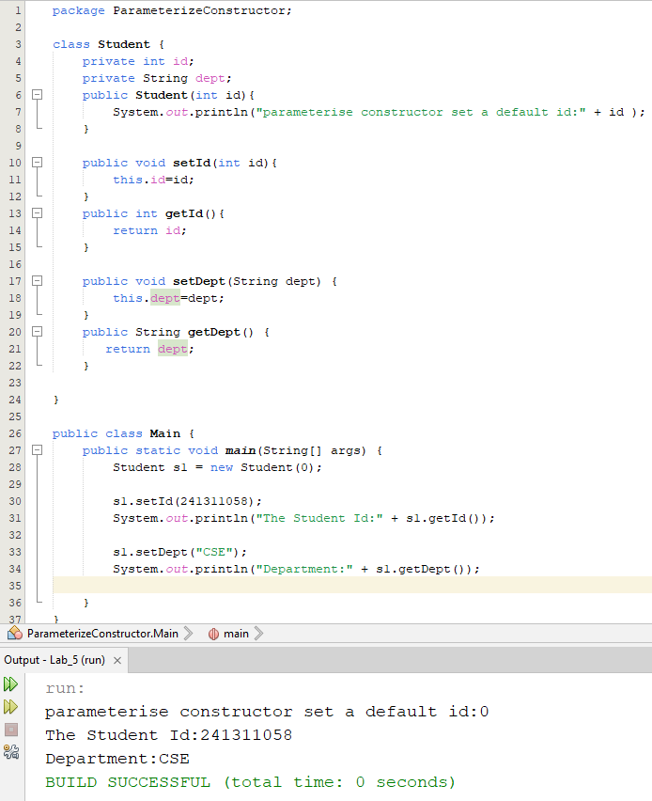

Problem-03: Write a Program to test Encapsulation.
